Acceptance Testing

# Story E-4: Delivery Schedule

As a courier, I want to know which delivers are assigned to me so that I can plan my deliver runs accordingly.

## Acceptance Criteria

Page displaying all delivers assigned to logged in courier.

## Test 1

When logged in as ALug, the Deliveries tab displays packages assigned to ALug.

### Evidence

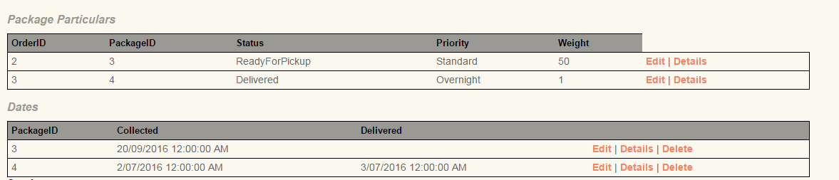

### Result

Pass – ALug can only see packages assigned to them.

## Test 2

When logged in as ABug, the Deliveries tab displays packages assigned to ABug.

### Evidence

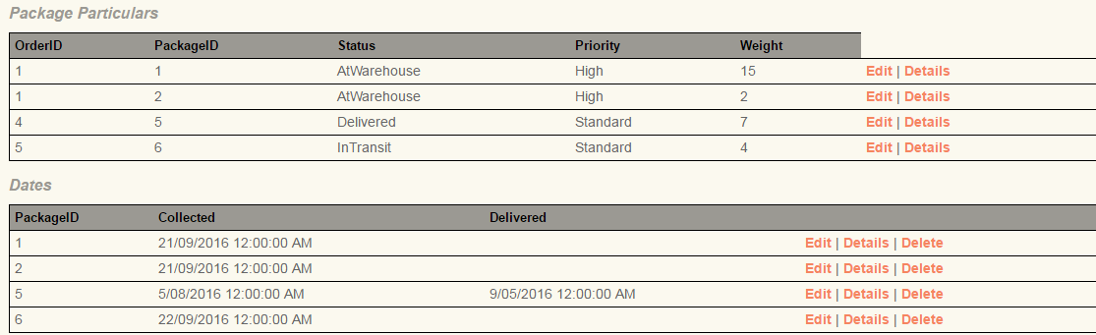

### Result

Pass – BLug can only see packages assigned to them.

## Overall Results

Test 1 – Pass  
Test 2 – Pass   
  
Both tests passed for E-4 and couriers can see only their assigned packages so E-4 has been implemented successfully.

# Story E-3: Package Priority

As a courier, I want to be able to know the priority of my packages so I can ensure customers are satisfied that their delivery was on time.

## Acceptance Criteria

This will merely be an addition to the order form. Under a section titled “Package details” a priority field will be included.

## Test 1

When logged in as a customer, there are additional fields to select the priority of the delivery.

### Evidence

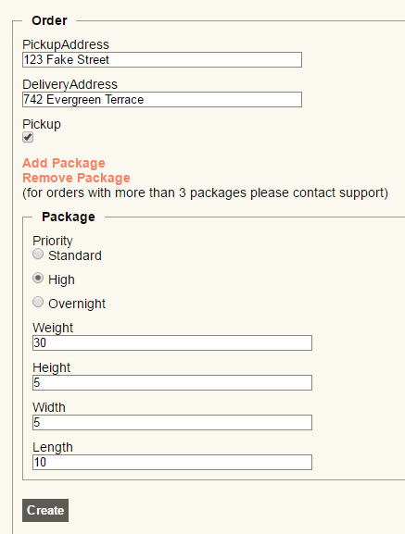

### Result

Pass – The customer has the option to select Standard, High or Overnight priority in the order form.

## Test 2

When logged in as admin, the orders tab will display the priority of submitted orders matching the selection of the customer’s order

### Evidence

  
  
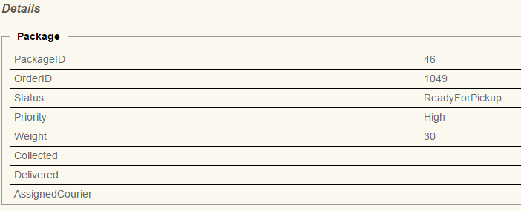

### Result

Pass – The admin can see the priority of packages by pressing ‘Details’ while in the Orders tab.

## Overall Results

Test 1 – Pass  
Test 2 – Pass

Both tests passed for E-3 allowing the customer to select a priority on the order form and the admin is able to view the selection (and courier once assigned) so Story E-3 has been implemented successfully.

# Story E-5: Change Status

As a courier, I want to be able to easily change the status of a package so that I can make my deliveries more efficiently.

## Acceptance Criteria

Form in ‘packages’ tab which allows courier to change package status  
Time should be logged automatically

## Test 1

A courier is able to change the status of PackageID 3.

### Evidence

### Result

Pass – The courier is able to update the Status for PackageID 3.

## Test 2

The updated status is available to view from administrator account.

### Evidence

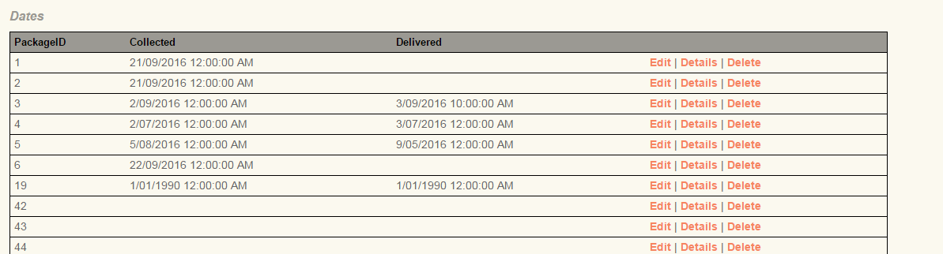

### Result

Pass – PackageID 3 has been updated from the admin’s account.

## Overall Results

Test 1 – Pass  
Test 2 – Pass

Both tests have passed for E-5 meaning the courier is able to change the status of a package and the update is viewable while logged into administrator’s account so E-5 has been successfully implemented.

# Story E-2: Package Type

As a courier, I want to be able to know the type of package I am deliver (weight, shape, etc.) so I can plan how much content can be packed into the truck per delivery.

## Acceptance Criteria

This will merely be an addition to the order form. Under a section titled ‘package details’ the weight, shape, etc. will be included.

## Test 1

When placing an order, the customer specifies the weight and dimensions of the package in the order form.

### Evidence

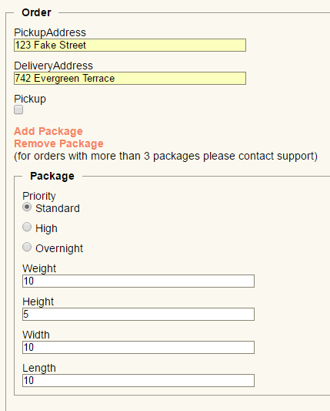

### Result

Pass – The customer specified the dimensions and weight: Weight – 10; Height – 5; Width – 10; Length – 10.

## Test 2

The dimensions are viewable for the administrator and the assigned courier.

### Evidence

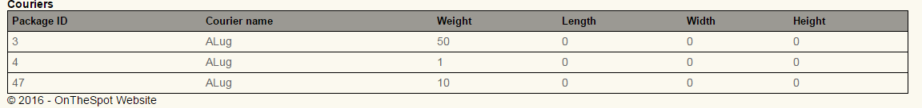

### Result

Fail – the weight is displayed but the length, width and height were not retrieved.

## Overall Results

Test 1 – Pass  
Test 2 – Fail

Story E-2 passed 1 of 2 tests. There are no issues displaying weight but an issue with displaying the length, width and height. This is a minor error but means E-2 has been unsuccessfully implemented.